Freight Rate Prediction Assessment Report
Candidate: Mohammad Ayyub

1. Objective
The objective of this assessment was to develop a machine learning model capable of predicting freight rates using the provided historical shipment data.
The assessment required:
- Training and validating a model using train-test.csv and producing results of test-set-prediction.csv and metrics.csv.
- Predicting freight rates for every shipment in validation.csv.
- Completing validation_predictions.csv.
- Predicting freight rates for the provided December scenario.
- Generating the December prediction chart using the supplied scoring utility.

2. Data Understanding
The development dataset consisted of historical freight shipments with numerical, categorical, geographical, and temporal features.
The primary target variable was:
- posted_rate
Important input features included:
- Pickup location (Avoided using for train model cause validation data had new locations as this was compensated by lat and long attr)
- Delivery location (Avoided using for train model cause validation data had new locations as this was compensated by lat and long attr)
- Pickup latitude & longitude
- Delivery latitude & longitude
- Distance
- Equipment type
- Weight
- Date
- Market Index
- Quote Signal
The validation dataset contained identical features except for the target variable.

3. Exploratory Data Analysis
Initial exploration focused on understanding:
- Feature distributions
- Missing values
- Data types
- Outliers
- Relationships between features and freight rate
Visualizations including histograms, scatter plots and correlation analysis were used to identify patterns within the dataset.
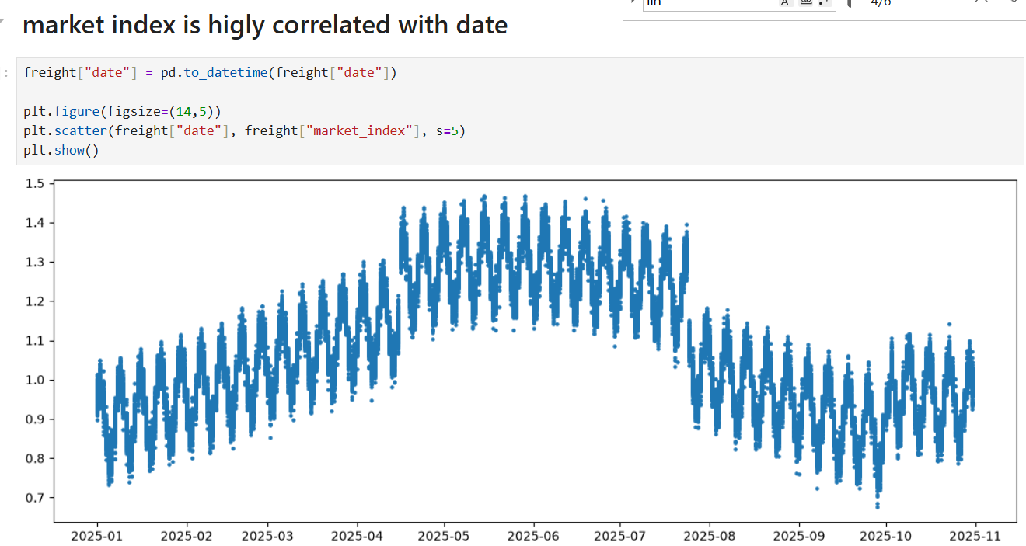
Key observations included:
- Distance showed a strong relationship with freight rate.
- Latitude and longitude effectively represented geographical information.
- Date required transformation before modelling into this format .
Month | day | weekday | week_of_year | day_of_year
- Certain numerical columns contained missing values market_index that was imputed.
- Invalid negative weight values were present within the dataset in weight forming as outlier so removed those rows of data.
a. Weight
Observation: The distribution appeared wider than expected, prompting validation for impossible values.
███████████████████
██████████████
████████
██

b. Pickup & Delivery Coordinates
Observation: Latitude and longitude showed discrete spikes rather than a continuous distribution.
Latitude

│ █
│ █
│ █ █ █
│ █ █ █
└─────────────────

c. Distance
Observation: Distance exhibited a right-skewed distribution.
Frequency

████████████████████
██████████
████
██
█
└──────────────────▶ Distance
Inference: Most shipments are short-haul, while long-haul shipments occur less frequently.

d. Market Index
Observation: The distribution displayed two distinct peaks (bimodal).

████
██████

██████
████
────────────────────────▶
Inference: Suggests two different market conditions, demand periods, or seasonal effects.

e. Quote Signal
Observation: The feature approximated a normal distribution.
Frequency

█
█████
█████████
█████
█
────────────────▶
Inference: Values are well-centered with few extreme observations.

f. Posted Rate
Observation: Posted Rate showed a right-skewed distribution with several high-value shipments.
Frequency

██████████████████
████████
████
██
█
└──────────────────▶ Posted Rate
Inference: Most freight rates are relatively low, while a small number of premium shipments create the long right tail.

4. Data Cleaning
Several preprocessing steps were performed to improve data quality.
Missing Values
Missing numerical values were handled using SimpleImputer.
The imputer was fitted only on the training data to prevent data leakage and later reused for all future predictions.
Invalid Records
Rows containing negative shipment weights were identified as invalid observations and removed before model training.
Date Processing
The original date column was converted into datetime format.
Additional temporal features were extracted:
- Month
- Day
- Weekday
- Week of Year
- Day of Year
These features allowed the model to capture seasonal patterns without directly using raw dates.

5. Feature Engineering
Instead of relying solely on categorical city names, geographical(lat,long) coordinates were utilized as numerical representations of locations.
This improves the model's ability to generalize to unseen pickup and delivery locations.
The engineered feature set included:
- Pickup Latitude
- Pickup Longitude
- Delivery Latitude
- Delivery Longitude
- Distance
- Weight
- Market Index
- Quote Signal
- Month
- Day
- Weekday
- Week of Year
- Day of Year
Equipment type remained as a categorical variable.

6. Categorical Encoding
Only the Equipment feature was one-hot encoded.
The encoder was configured using:
- handle_unknown="ignore"
This enables inference on unseen equipment categories without causing runtime errors.
The fitted encoder was saved and reused during inference.
Pickup and delivery names were intentionally excluded from one-hot encoding in the final model.
Although including city names slightly improved validation accuracy, one-hot encoding cannot generalize to unseen locations present in hidden validation data.
Instead, location information was represented using latitude and longitude.

7. Train/Test Split
The development dataset was divided into training and testing subsets.
The training data was used for:
- fitting the imputer
- fitting the encoder
- model training
- hyperparameter optimization
The testing data was reserved exclusively for final evaluation.
This ensured an unbiased estimate of model performance.

8. Model Development
Multiple regression algorithms were evaluated as the problem was supervised regression which is continuous and non linear in nature.
The models included:
- Random Forest Regressor
- LightGBM
- XGBoost Regressor
Each model was evaluated using cross-validation and identical evaluation metrics.

9. Hyperparameter Tuning
The final XGBoost model underwent hyperparameter tuning using RandomizedSearch.
Parameters optimized included:
- Number of estimators
- Learning rate
- Maximum tree depth
- Minimum child weight
- Regularization
- Row sampling
- Column sampling
The tuned configuration produced improved validation performance while maintaining strong generalization.

10. Model Comparison
Several models were compared using identical evaluation metrics.
Evaluation metrics included:
- RMSE
- MAE
- MAPE
- R²
Observations:
- Random Forest achieved lower training error but exhibited greater overfitting.
- LightGBM produced competitive results.
- XGBoost achieved the best balance between training performance and validation performance.
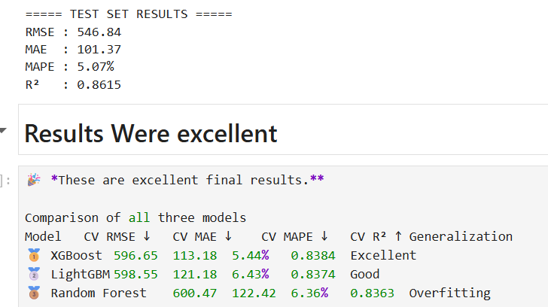
For this reason, XGBoost was selected as the final production model.

11. Final Model Performance
The selected XGBoost model demonstrated consistent performance across cross-validation folds.
Evaluation metrics included:
- Root Mean Squared Error (RMSE)
- Mean Absolute Error (MAE)
- Mean Absolute Percentage Error (MAPE)
- R² Score
The relatively small difference between training and validation metrics indicates that the model generalized well and did not exhibit significant overfitting.

12. Model Persistence
To ensure reproducibility and enable inference without retraining, the preprocessing pipeline and trained model were persisted.
Saved artifacts:
- imputer.pkl
- onehot_encoder.pkl
- best_xgboost_model.pkl
These artifacts were reused during prediction on both the hidden validation dataset and the December dataset.

13. Validation Prediction
The hidden validation dataset was processed using the identical preprocessing pipeline used during training.
The workflow consisted of:
- Feature engineering
- Missing value imputation
- Equipment encoding
- Prediction using the saved XGBoost model
The resulting predictions were exported as:
validation_predictions.csv
containing:
load_id,predicted_rate

14. December Prediction
The December prediction dataset contained fewer features than the original training dataset.
Additional preprocessing steps were therefore required.
These included:
- reconstructing engineered date features
- restoring latitude and longitude
- applying the saved imputer on addon features Market Index and Quote Signal
- applying the saved encoder
Since certain features such as Market Index and Quote Signal were unavailable, representative values derived from the development dataset were used to complete the feature set before inference.
The saved XGBoost model was then used to predict freight rates for each day in December.

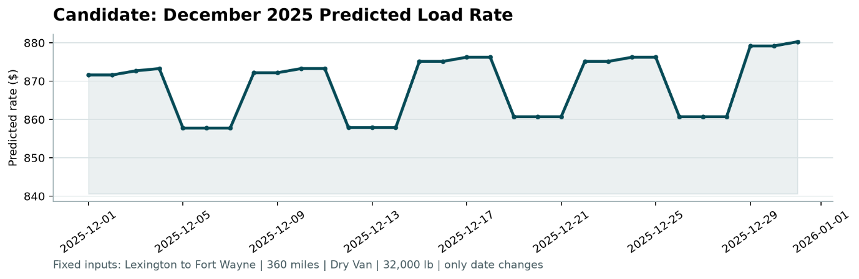

15. Score Utility Modification
During local validation, the provided score.py utility expected exactly 12,000 prediction rows.
However, after removing invalid observations containing negative shipment weights during preprocessing, this strict row-count validation prevented local verification.
A minimal modification was therefore made to relax the fixed row-count requirement while preserving all remaining validation logic, including:
- column validation
- duplicate checks
- positive prediction checks
- December prediction validation
- chart generation
This modification was used solely for local verification.

16. Conclusion
The final solution follows a complete end-to-end machine learning workflow, including data exploration, preprocessing, feature engineering, model development, evaluation, and deployment-oriented inference.
Although including pickup and delivery names as one-hot encoded features provided marginally higher validation accuracy during experimentation, the final production model intentionally relied on latitude and longitude for geographic representation. This design choice improves robustness when predicting shipments involving previously unseen locations, making the solution more suitable for real-world deployment and hidden evaluation datasets.
The final submission includes:
- Trained XGBoost model
- Saved preprocessing pipeline
- Hidden validation predictions
- December predictions
- Generated December prediction chart
- Complete reproducible project repository
This approach emphasizes both predictive performance and practical generalization, ensuring that the model remains reliable when deployed on previously unseen freight routes.

